Year 1 Home Learning – Week Beginning 27.04.
Hi Year 1! I hope you are all staying safe at home and enjoying the sunshine if you can! Remember you are all doing amazing and I am missing you all very much. Here are your home learning tasks for this week.
Phonics – Choose one of the boxes below – you should know which sounds are your current phase.
Can you read these 4 sounds?
ay ou ie ea
Can you read all four of the words below?
play
cloud
pie
tea
Can you draw the sound buttons underneath the words?
Can you put each word into a different sentence?
Can you put all of the words into the same sentence?

Can you read these 4 sounds?
ee ch sh ck
Can you read all four of the words below?
beep
chip
shop
kick

Can you draw the sound buttons underneath the words?
Can you put each word into a different sentence?
Can you put all of the words into the same sentence?

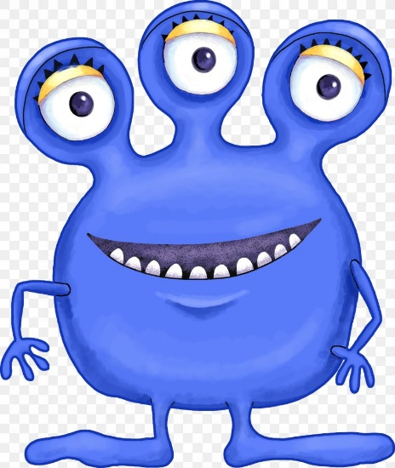
Writing -
Underneath you will see an image of a character. Can you write either 2 or 2 descriptive sentences about this character? I will add some sentence prompts to help you if you are stuck. Remember your capital letters, full stops and finger spaces! You could even join two ideas together using the word ‘and’.

Prompts – The _________ monster has _______ feet.
The _________ monster has _______ eyes.

Maths -
I would like you to use any objects in your house to help you answer these questions, or you could draw 20 squares and cut them out!
20 – 5 =
20 – 7 =
20 – 3 =
20 – 6 =
20 – 9 =
Missing Box -
20 - = 12
20 - = 14
- 5 = 15
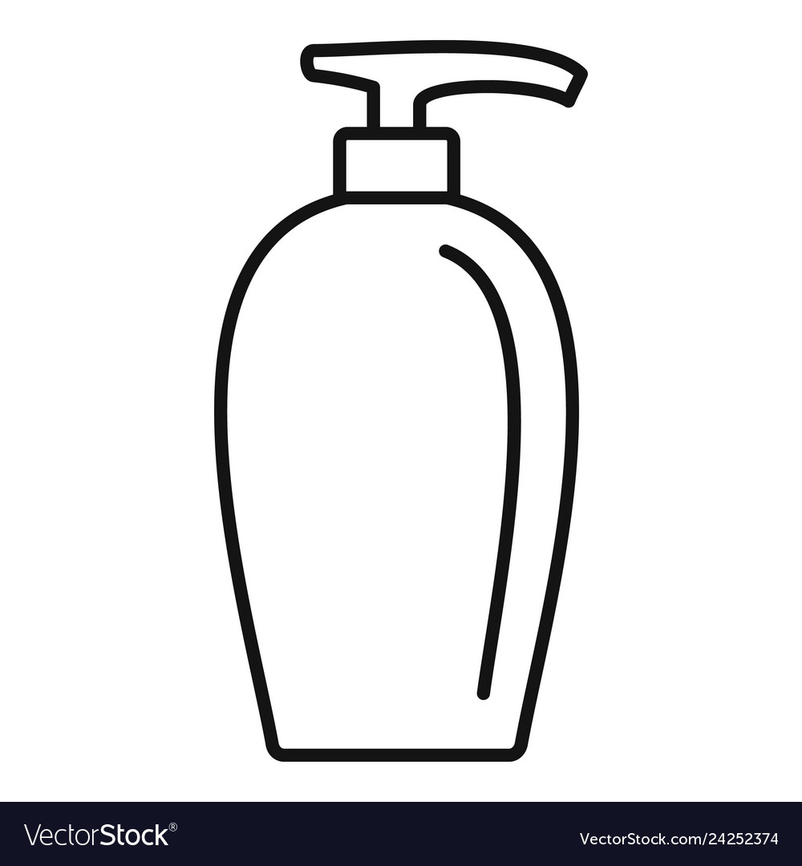
Art and Design
I would like you to design your own label for a soap bottle! Try and make it exciting and colourful so it encourages people to wash their hands!
Mindfulness -
Can you write a card for a keyworker? (Someone who you know who is working really hard right now to help everybody). Write a thank you card for them I am sure they will be delighted!
Last but not least – stay at home and stay safe, you are all amazing and I am sure we will all be back together soon. Keep smiling!
Love from Miss Tomlinson and Miss King x

