Year 1 Home Learning – Week Beginning 11.05
Hi Year 1! I hope you are all staying safe at home and enjoying the time with your family! Remember you are all doing amazing and we are missing you all very much. Here are your home learning tasks for this week.
Phonics – Choose one of the boxes below – you should know which sounds are your current phase.
Can you read these 4 sounds?
wh aw ey oe
Can you read all four of the words below?
wheels
crawl
monkey
toes
Can you draw the sound buttons underneath the words?
Can you put each word into a different sentence?
Can you put all of the words into the same sentence?

Can you read these 4 sounds?
ai ee z qu
Can you read all four of the words below?
rain
beep
zip
quiz
Can you draw the sound buttons underneath the words?
Can you put each word into a different sentence?
Can you put all of the words into the same sentence?

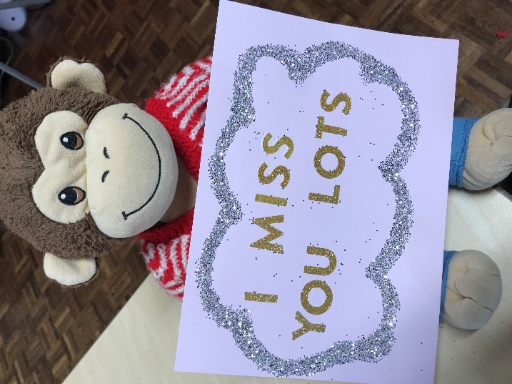
Writing -
This week I would like you to write a letter to Max (remember our class monkey?) about everything that you have been doing whilst you have been at home, he would love to know!
You could tell him about;
- A book you have read
- A film you have watched
- Some sweets that you ate!
- A game that you have played
- Some homework that you have completed
- A walk that you have been on
- Your favourite song
It could be absolutely anything! See if you can remember the features of a letter – I will add a template onto the bottom.
Max is really excited to read your letters!
Maths -
For maths this week I am giving you two different options – I will put a link below to ‘White Rose Maths’ which has daily lessons that you can get involved in if you would like to revisit lessons we have done before and also begin to learn some new things. My task is below – there are two groups of cards, the green cards are our 10 times tables (counting in 10’s) and the blue cards are our 5 times tables (counting in 5’s) - can you put them in the correct order? Let me know how you get on!
https://whiterosemaths.com/homelearning/year-1/

Science -
Our science topic for this half term would be all about comparing the seasons of spring and summer. This week we are going to focus on the season of summer which is fast approaching! I will put an outline of a person below – can you dress them in a way that is suitable for the summer? Label your design and write a sentence or two explaining why you have dressed them that way!
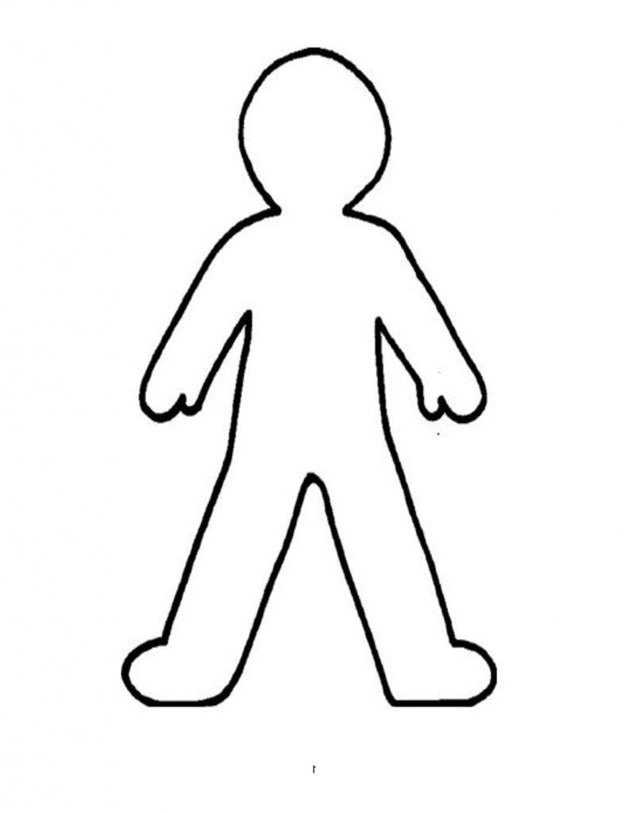

Geography -
Our new Geography topic should have been all about the United Kingdom this half term.
This week we are going to focus on ‘England’ and its capital city which is London – can you design a poster all about London? I would like you to try and write about 2 landmarks, things to do, things to eat and the weather! Have fun!
Use this website to help you - http://projectbritain.com/london/facts.htm
Last but not least – stay at home and stay safe!! We miss you and can’t wait to be back in our classroom!
Love Miss Tomlinson and Miss King x

