Year 1 Home Learning – Week Beginning 04.05
Hi Year 1! I hope you are all staying safe at home and enjoying the time with your family! Remember you are all doing amazing and we are missing you all very much. Here are your home learning tasks for this week.
Phonics – Choose one of the boxes below – you should know which sounds are your current phase.

Can you read these 4 sounds?
th ng j v
Can you read all four of the words below?
van
thin
jump
ring
Can you draw the sound buttons underneath the words?
Can you put each word into a different sentence?
Can you put all of the words into the same sentence?

Can you read these 4 sounds?
ue oy ir ph
Can you read all four of the words below?
blue
enjoy
girl
dolphin
Can you draw the sound buttons underneath the words?
Can you put each word into a different sentence?
Can you put all of the words into the same sentence?

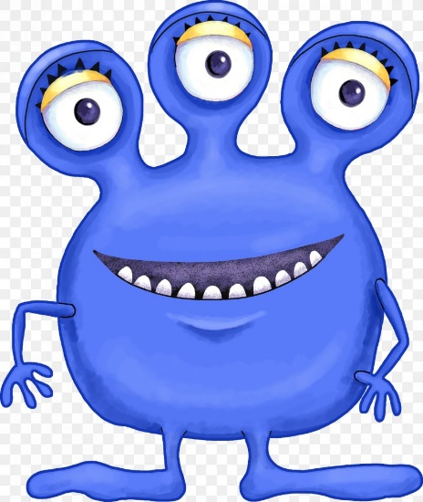
Writing -
I would like you to think about question marks this week and when we use question marks in our writing. I am going to keep the image of the monster below as I want you to think of 4 or 5 questions you would like to ask the monster. It could be anything!! It could be; what is your favourite food? What size are your feet? Are you a happy monster? Are you a scary monster?
If you are unsure about question marks here is a link to the BBC bitesize lesson which should help you - https://www.bbc.co.uk/bitesize/articles/z7hc47h.
Once you have completed your questions I would like you to design a picture of the place where you think this monster lives – if you feel like a challenge you could even think of a name too! Be creative!

Remember – our questions start with; who, what, why, where, when and how!
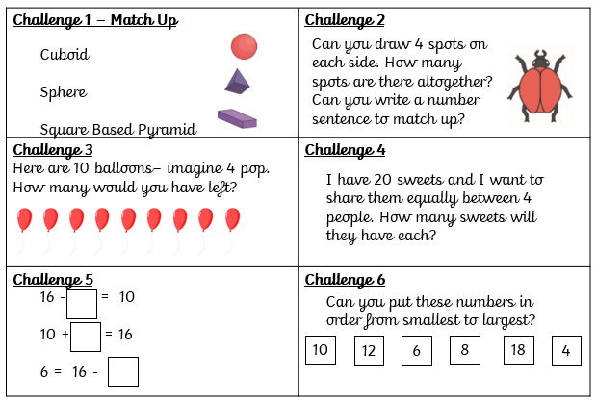
Maths -
For maths this week I am giving you two different options – I will put a link below to ‘White Rose Maths’ which has daily lessons that you can get involved in if you would like to revisit lessons we have done before and also begin to learn some new things. My task is below – there are 6 questions covering 6 different areas of Maths. Give it a go – tell me how you got on!
https://whiterosemaths.com/homelearning/year-1/

Science -
Our science topic for this half term would be all about comparing the seasons of spring and summer – below I will show you two pictures, one of spring and one of summer. Can you write down a list of words to describe each picture? Then write a sentence explaining why they seem different.
Spring
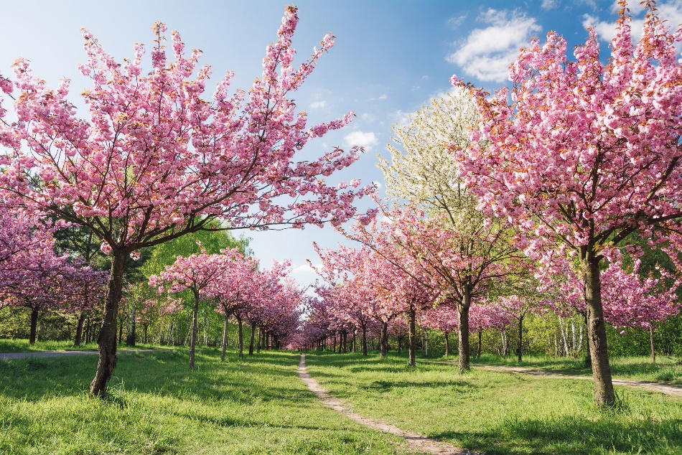
Summer
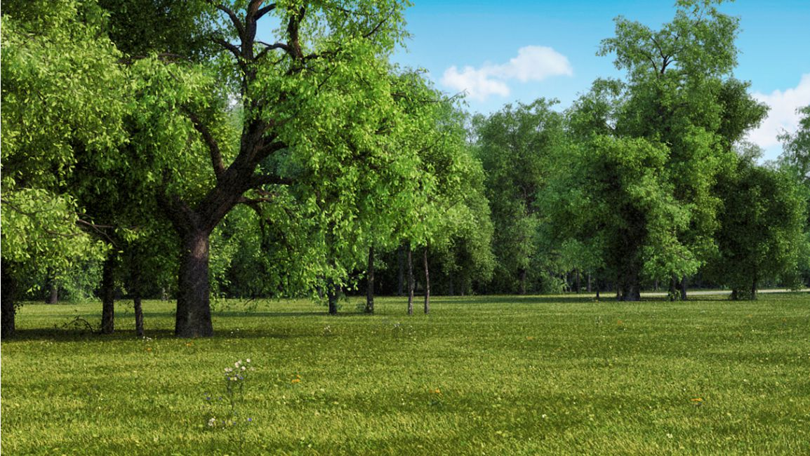
Once you have finished this – can you write down some ideas of activities you might do in the summer that you don’t do at any other point in the year? Think about the weather – how might this help…
Geography -
Our new Geography topic should have been all about the United Kingdom this half term.
https://www.bbc.co.uk/bitesize/topics/zyhp34j/articles/z4v3jhv - have a look at the link and try and write down the 4 countries that make up the United Kingdom – can you draw a picture of each flag?
Last but not least – stay at home and stay safe!! We miss you and can’t wait to be back in our classroom!
Love Miss Tomlinson and Miss King x

