Year 1 Home Learning – Week Beginning 15th June
Hi Year 1! I hope you are all safe and well at home and I hope you are all still smiling! Me and Miss King can’t wait to see you all again, but here are your home learning tasks to keep you busy this week. We hope to see you soon!
Phonics – Choose one of the boxes below – you should know which sounds are your current phase. If you wanted you could even do both!
Can you read all six of the words below?
trees
trip
track
stairs
stars
stamp
Can you put each word into a different sentence?

Can you read all four of the words below?
said
so
milk
silk
Can you put each word into a different sentence?

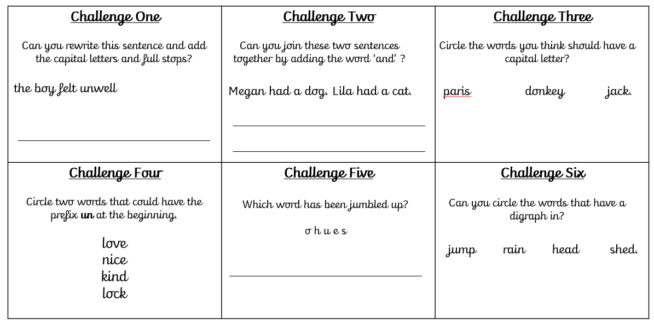
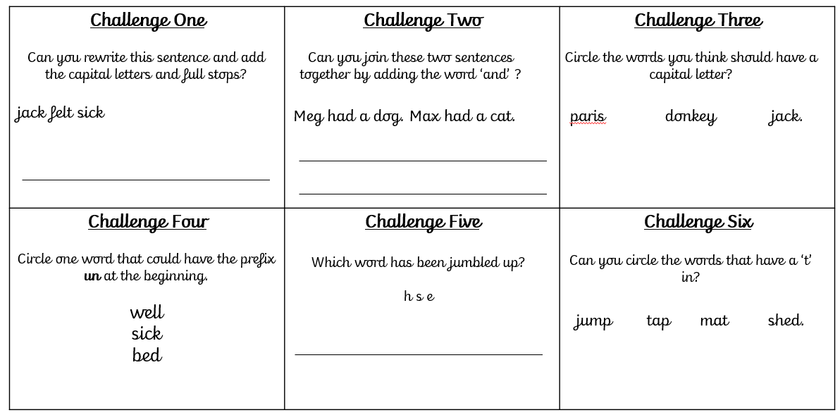
Writing -
Please use the link below to access daily sessions from BBC bitesize. They are really fun and are covering lots of different things! I will also put two SPAG activity mats below if you would like to do this as well – choose which one you would like to do.
Here is the link for BBC Bitesize -
https://www.bbc.co.uk/bitesize/tags/zjpqqp3/year-1-and-p2-lessons

Maths -
For maths this week I am giving you two different options – I will put a link below to ‘White Rose Maths’ which has daily lessons that you can get involved in if you would like to revisit lessons we have done before and also begin to learn some new things. My task is below – I would like you to complete the activity about sharing below – see if you can remember what we did in class. Remember each person must have an equal amount!
https://whiterosemaths.com/homelearning/year-1/
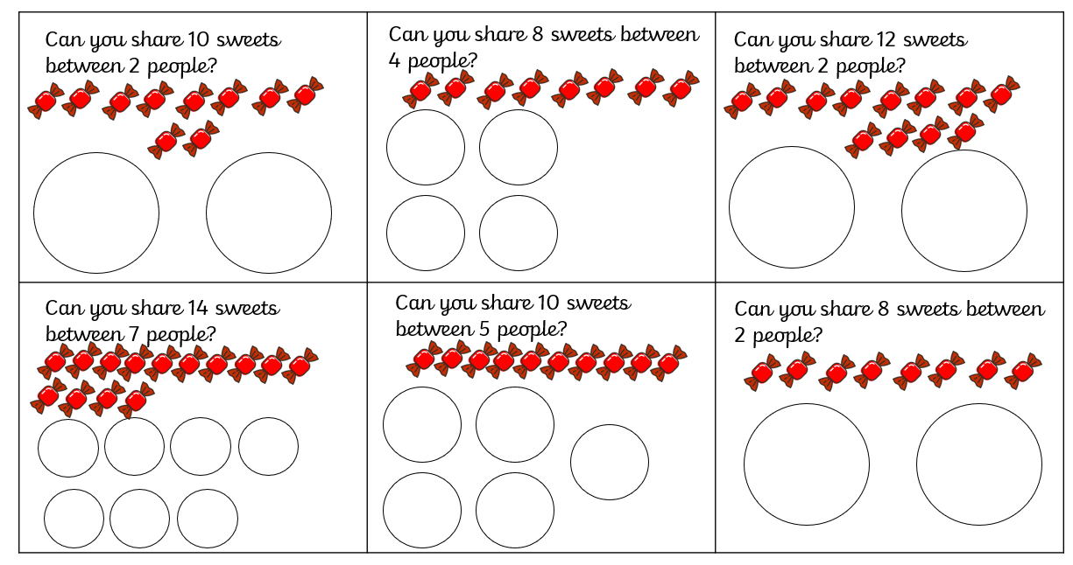
Science -
Our new science topic for this half term is all about ‘Everyday Materials’ – if you didn’t get chance to complete your material hunt last week you can still do that this week as your next activity leads on from that.
If you completed your material hunt I would now like you to write down 3 words to describe each material, use the vocabulary box to help you! (It is underneath the table).
Plastic
Wood
Metal
Paper

Vocabulary Box -
rough smooth soft hard dry wet tough bumpy
shiny lumpy prickly fuzzy gritty rubbery soggy
gloopy sticky squashy crunchy

History
Our new topic for this half term is all about ‘Great Explorers’. This week we will be learning all about a great explorer called ‘Ibn Battuta’ – he was born in Tangier in Morocco.
It is estimated that he travelled over 73,000 miles visiting the equivalent of 44 modern countries in his lifetime.
On his journey he conquered thieves, sickness and several injuries, but he managed to see so many wonderful things!
For this lesson I would like you to use your prediction skills – I will name 3 different places that Ibn Battuta came across on his journey, I would like you to draw 3 pictures and write down 1 sentence about each picture saying what you think he discovered there and what it was like. Here are the 3 places:
1) Delhi in India
2) A Palace in China
3) A House Made From Salt
I will add a link here – the link is for older children but the video may help you.
https://www.bbc.co.uk/teach/class-clips-video/ks2-ibn-battuta/zmqgnrd

Art
Our Art topic for this half term is all about self- portraits. I would like you to have a go at drawing a picture of your face – make sure you focus on the details of your facial features.
Last but not least – stay safe!! We miss you and can’t wait to be back in our classroom!
Love Miss Tomlinson and Miss King x

