Year 1 Home Learning – Week Beginning 22nd June
Hi Year 1! I hope you are all safe and well at home and I hope you are all still smiling! Me and Miss King can’t wait to see you all again, but here are your home learning tasks to keep you busy this week. We hope to see you very soon!
Phonics – Choose one of the boxes below – you should know which sounds are your current phase. If you wanted you could even do both!
Can you read all six of the words below?
bench
branch
crunch
scrunch
school
house
Can you put each word into a different sentence?

Can you read all four of the words below?
he
she
pram
print
Can you put each word into a different sentence?

Writing -
Please use the link below to access daily sessions from BBC bitesize. They are really fun and are covering lots of different things! I will also put two SPAG activity mats below if you would like to do this as well – choose which one you would like to do.
Here is the link for BBC Bitesize -
https://www.bbc.co.uk/bitesize/tags/zjpqqp3/year-1-and-p2-lessons

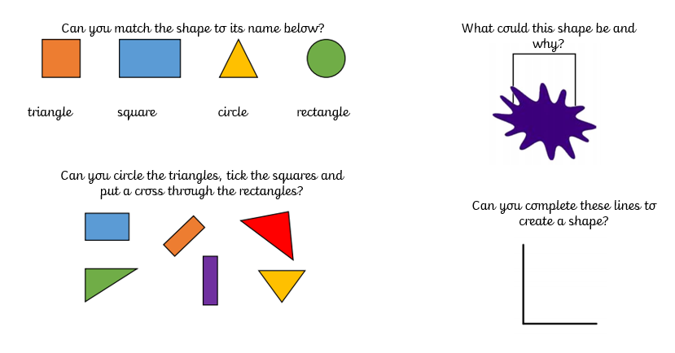
Maths -
For maths this week I am giving you two different options – I will put a link below to ‘White Rose Maths’ which has daily lessons that you can get involved in if you would like to revisit lessons we have done before and also begin to learn some new things. My task is below – I would like you to complete the activity about shapes.
https://whiterosemaths.com/homelearning/year-1/

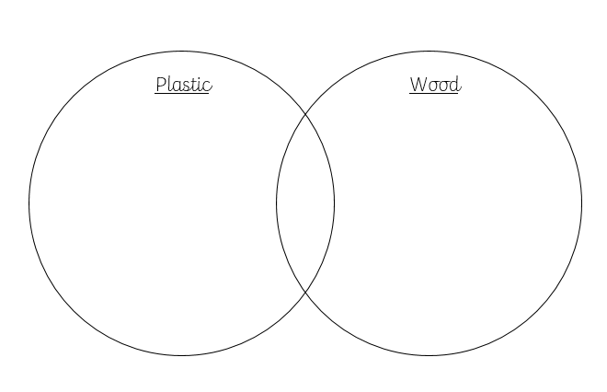
Science -
Our new science topic for this half term is all about ‘Everyday Materials’ – I would like you to sort some of the objects in your house. Can you find objects that are made out of wood and plastic and put them into the diagram below. Underneath can you write down 2 things that are similar about the objects and 2 things that are different.

History
Our new topic for this half term is all about ‘Great Explorers’. This week we will be learning all about a great explorer called Christopher Columbus. Ask someone at home if they know anything about him! C
Christopher Columbus lived at a time when people in Europe did not know North and South America existed. He learned how to sail in a wooden ship with sails attached, he learned to find his way at sea using the sun and the stars. How clever!
I am going to attach a link here for you to look at, this will give you some more information about Christopher Columbus. I would like you to write down 3 questions you would like to ask Christopher Columbus if you had the chance.
https://www.bbc.co.uk/bitesize/topics/zhpchbk/articles/znchkmn

Art
Our Art topic for this half term is all about self- portraits. I would like you to have a go at drawing a picture of someone else in your house, think of their features and try and make it look like them. If you would like to take a photograph of your drawing you could email them to school so I can have a look!
Last but not least – stay safe!! We miss you very much!
Love Miss Tomlinson and Miss King x

