Year 1 Home Learning – Week Beginning 29th June
Hi Year 1! I hope you are all safe and well at home and I hope you are all still smiling! Here are your home learning tasks to keep you busy this week.
Phonics – Choose one of the boxes below – you should know which sounds are your current phase. If you wanted you could even do both!
Can you read all six of the words below?
bathroom
splashing
sparkling
glitter
shampoo
melting
Can you put each word into a different sentence?
Can you put each word into a different sentence?

Can you read all five of the words below?
ask
belt
best
bush
camp
Can you put each word into a different sentence?

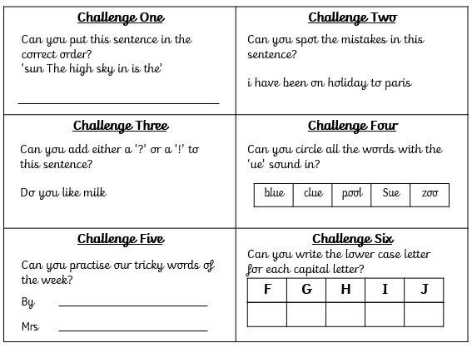
Writing -
Please use the link below to access daily sessions from BBC bitesize. They are really fun and are covering lots of different things! I will also put two SPAG activity mats below if you would like to do this as well – choose which one you would like to do.
Here is the link for BBC Bitesize -
https://www.bbc.co.uk/bitesize/tags/zjpqqp3/year-1-and-p2-lessons

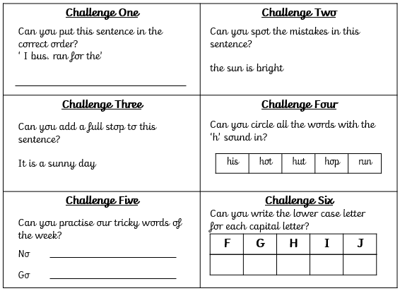

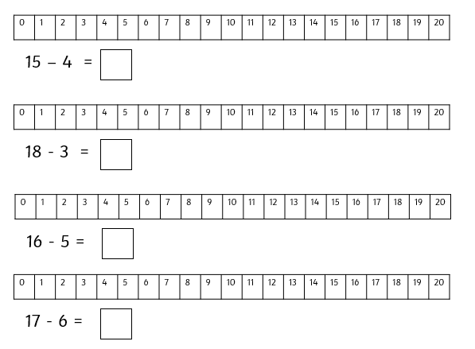
Maths -
For maths this week I am giving you two different options – I will put a link below to ‘White Rose Maths’ which has daily lessons that you can get involved in if you would like to revisit lessons we have done before and also begin to learn some new things. My task is below – I would like you to complete the activity about taking away using a number line.
https://whiterosemaths.com/homelearning/year-1/

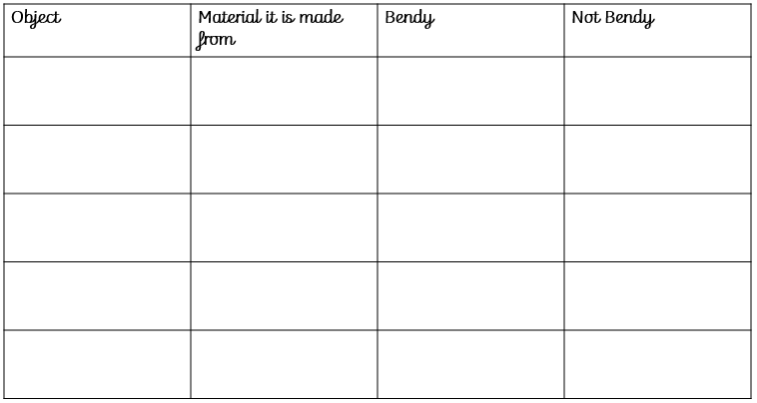
Science -
Our new science topic for this half term is all about ‘Everyday Materials’ – I would like you to find four different objects inside or outside of your house, they all have to be made from different materials. When you have chosen four objects – complete the table below!

History
Our new topic for this half term is all about ‘Great Explorers’. This week we will be learning all about a great explorer called Neil Armstrong. Ask someone at home if they know anything about him!
Neil Armstrong was born in America in 1930. He was the first man to walk on the moon in 1969! You can watch a video clip of the landing here - https://www.youtube.com/watch?v=XkKPt7XGMns
I am going to attach a link here for you to look at, this will give you some more information about Christopher Columbus. I would like you to write down 3 questions you would like to ask Neil Armstrong if you had the chance.
I would also like you to write down 5 things you would take with you if you had the chance to travel to the moon!
https://www.bbc.co.uk/bitesize/topics/zjwvb82/articles/zhx4k2p

Art
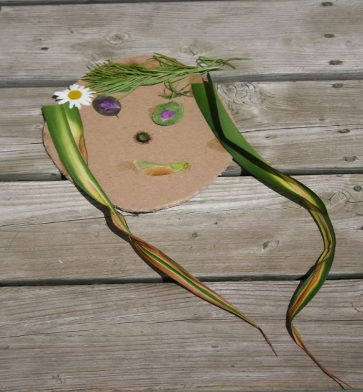
Our Art topic for this half term is all about self- portraits. I would like you to have a go at using outdoor resources such as sticks and leaves to create an image of yourself or someone in your house. I will show you some examples below.
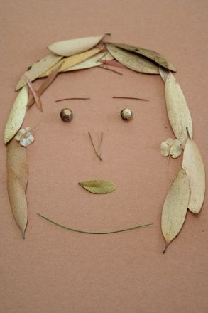
Last but not least – stay safe!! We miss you very much!
Love Miss Tomlinson and Miss King x

