Year 1 Home Learning – Week Beginning 8th June
Hi Year 1! I hope you have all enjoyed your half term and the lovely sunshine we have had, hopefully it will return soon! I hope you are all staying safe here are your home learning tasks for this week.
Phonics – Choose one of the boxes below – you should know which sounds are your current phase. If you wanted you could even do both!
Can you read all six of the words below?
branch
scrunch
lunch
crunch
munch
lunchbox
Can you put each word into a different sentence?

Can you read all four of the words below?
sand
hand
band
pond
Can you draw the sound buttons underneath the words?
Can you put each word into a different sentence?

Writing -
Can you add the suffix ‘ing’ to these words. Can you put them into sentences? Remember a suffix is what we add to the end of words.
hunt
sing
eat
jump
ring

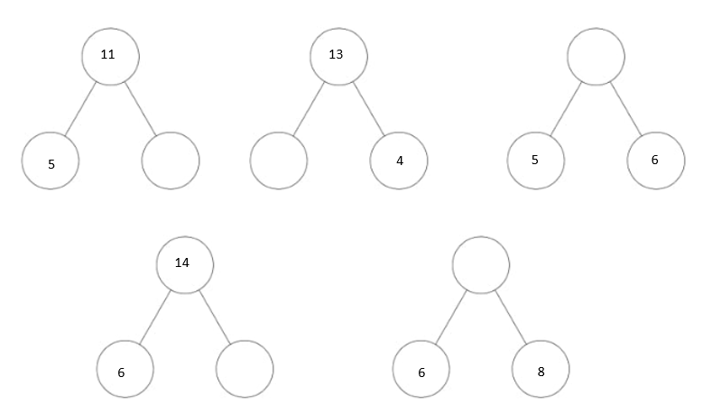
Maths -
For maths this week I am giving you two different options – I will put a link below to ‘White Rose Maths’ which has daily lessons that you can get involved in if you would like to revisit lessons we have done before and also begin to learn some new things. My task is below – I would like you to use the part whole model to find the missing part. There are 5 questions below.
https://whiterosemaths.com/homelearning/year-1/
Science -
Our new science topic for this half term is all about ‘Everyday Materials’ - this week I would like you to go on a material hunt either inside your house or outside. In the table below I would like you to write objects that you can find that are made out of that particular material. If you would like to draw pictures as well that would be great!
Plastic
Wood
Metal
Paper

History
Our new topic for this half term is all about ‘Great Explorers’. I want you to think about someone who is important to you and why they are important. I want you to draw a picture of this person and write down 3 sentences about why they are important to you.

Last but not least – stay safe!! We miss you and can’t wait to be back in our classroom!
Love Miss Tomlinson and Miss King x

