Hi Year 2,
I hope you have enjoyed the lovely weather we’ve had this week. Here are your new home learning tasks.
Take care and stay safe.
Lots of love
Miss Kennedy
Maths
Please follow the link http://whiterosemaths.com/homelearning.year-2/
There are daily lessons, videos to watch and activities to complete. The link can be used for daily Maths lessons.
You can also use https://www.bbc.co.uk/bitesize/tags/z7s22sg/year-2-and-p3-lessons to find a selections of Maths work to complete.

English
Work your way though the daily English lessons on https://www.bbc.co.uk/bitesize/tags/z7s22sg/year-2-and-p3-lessons
Have a look at http://www.ictgames.com/ and https://www.topmarks.co.uk/ for a good selection of English and Maths games to play at home.

Science
Our Science topic this half term is habitats.
This week I would like you to look at food chains.
A food chain shows how each animal gets its food. Food chains are one of the ways that living things depend on each other to stay alive.
Watch https://www.bbc.co.uk/bitesize/topics/zx882hv/articles/z3c2xnb to learn more.
I would like you to write definitions for the following new vocabulary:
- producer
- consumer
- predator
- prey
The arrows in a food chain mean ‘is eaten by’. Can you name which animal is eating which in the food chain below?
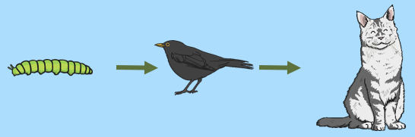
The caterpillar is eaten by the bird.
The bird is eaten by the cat.

Can you create your own food chains?
How many can you think of?
Here are some ideas for you to include.

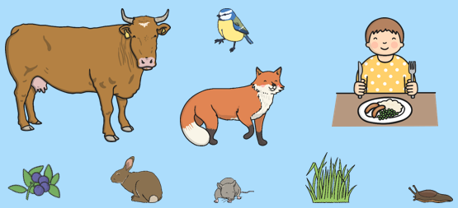

Remember to draw the arrows to show what eats what.

EXTRA CHALLENGE
Can you label the different parts of the food chain with the new vocabulary?
(producer, consumer, predator, prey)

History
Our topic this half term is ‘Children during World War 2’.
Following on from last week looking at The Blitz, I would like you to research air raid shelters this week. The most popular air raid shelter was an Anderson shelter. What information can you find out about Anderson shelters? Present your information as a poster.

Each year I ask the children in Year 2 to create their own Anderson shelters as part of a homework project. I would love for you to have a go too. Once you have researched, you will know what they look like. Here are a few examples for you to look at:

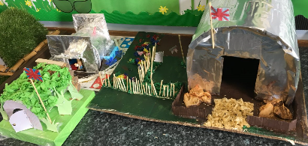
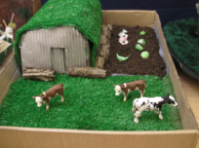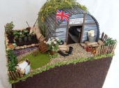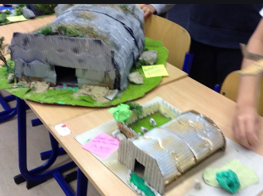
You can either create a model using things you have at home or you could draw and label your design. I would love to see your finished work.

Music
Have a look at the website we use for teaching music in school. I know how much you enjoy singing so why not learn a new song at home? https://www.singup.org/singupathome

Twinkl
https://www.twinkl.co.uk/home-learning-hub
Follow this link to the home learning hub. It us updated daily with new activities. Why not have a go at practising your handwriting or spelling the Year 2 common exception words. Have a look, I’m sure you’ll find something you will like.

