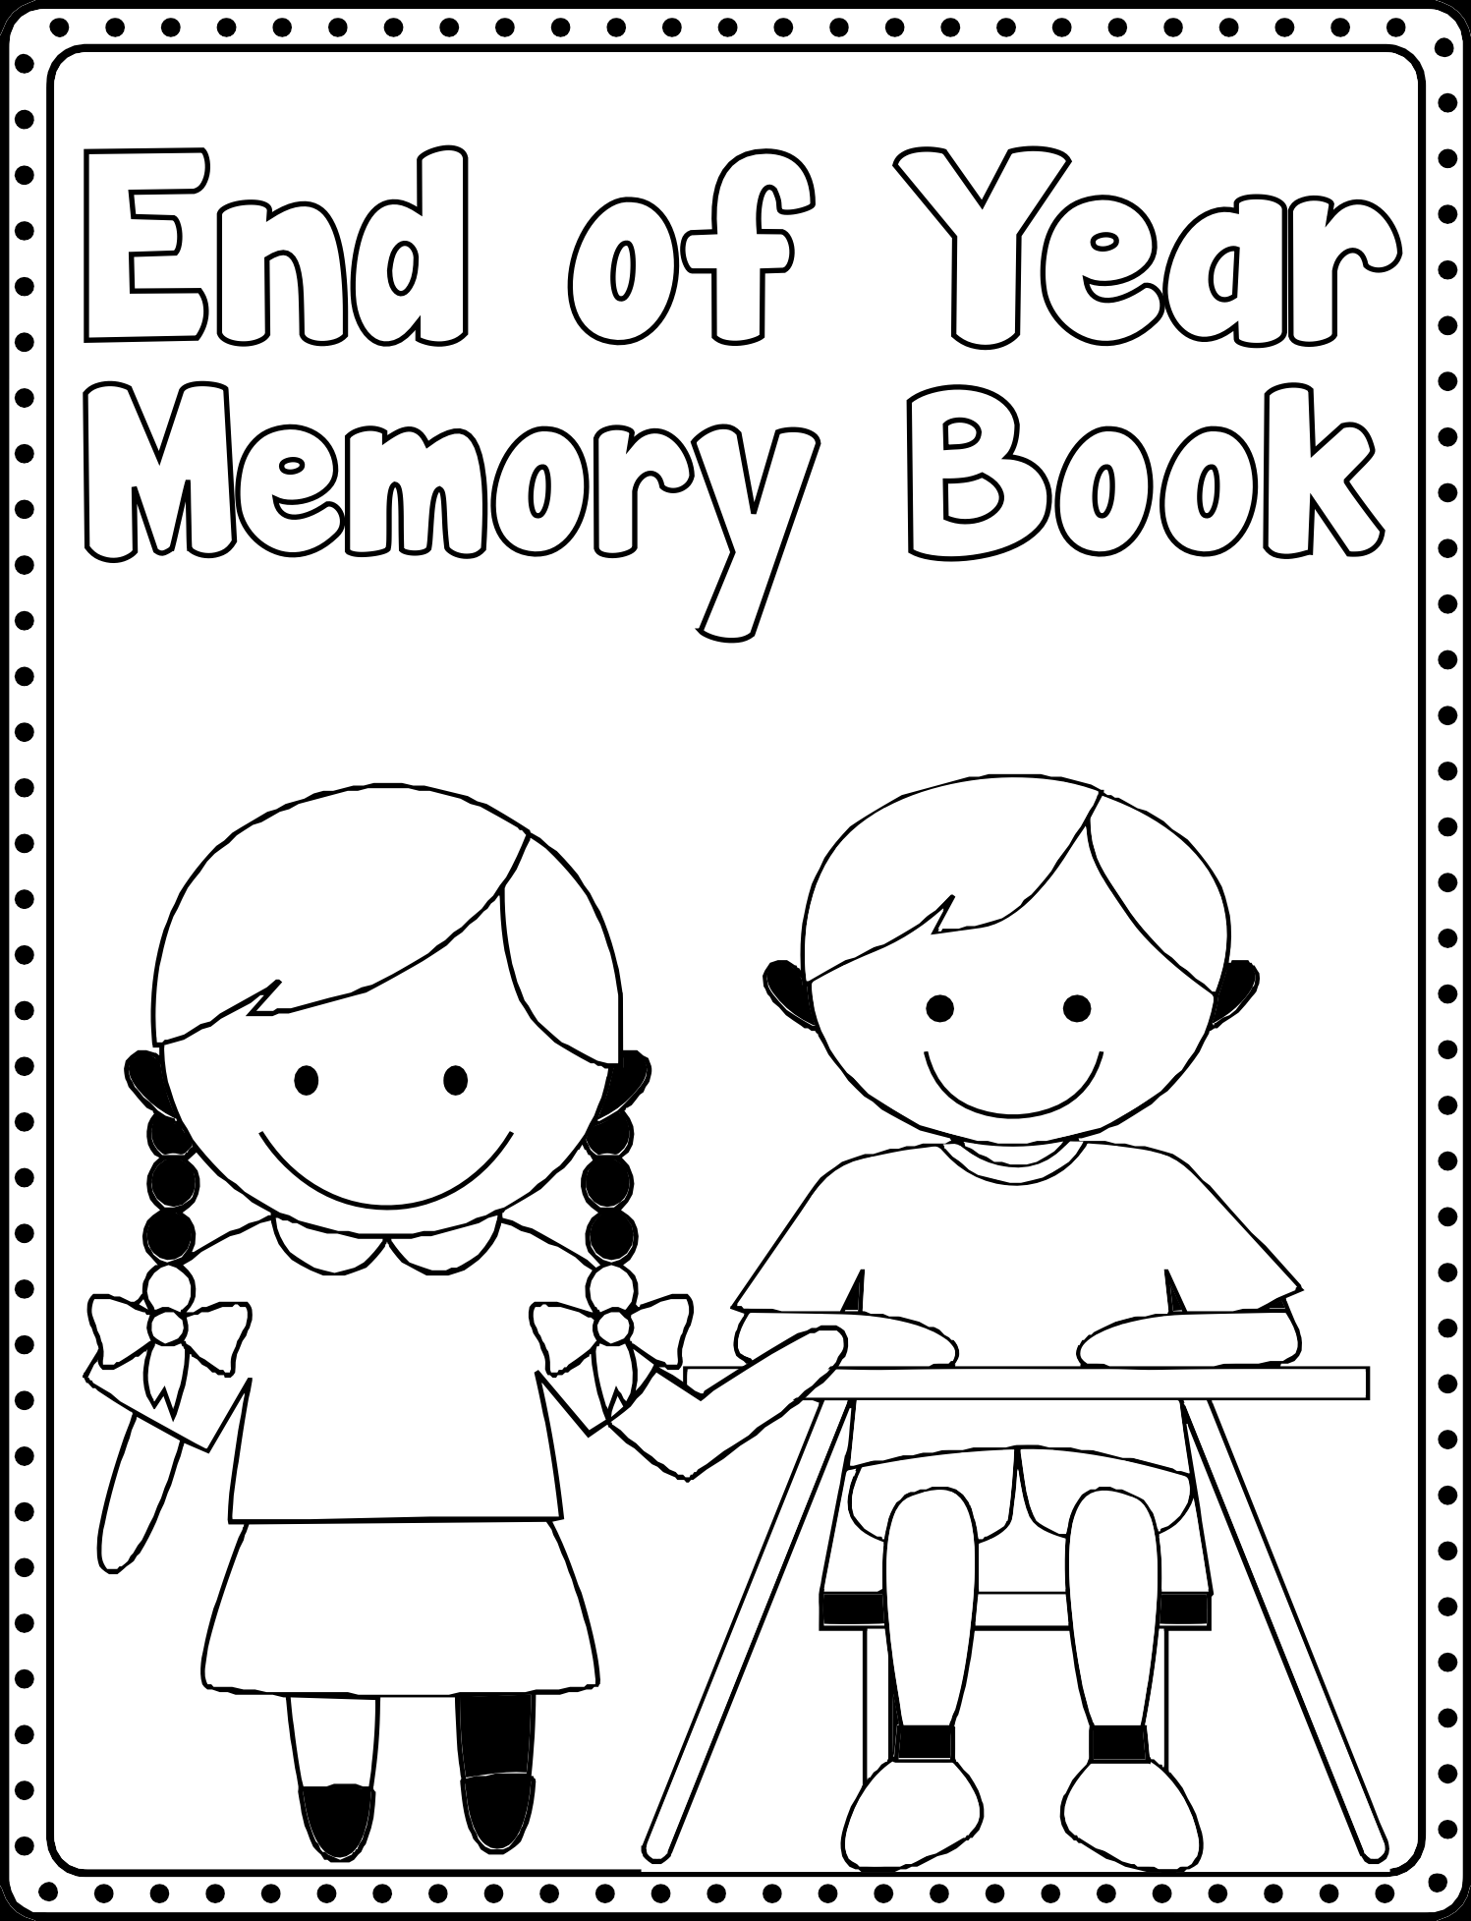

Name:____________________________

Grade:____________________________

Year:_____________________________

This is me

I am _____ years old

My favorite food is
__________________________________.

My favorite book is
__________________________________.

My favorite subject this

year was _____________________

because ________________________

___________________________________

Name:_________________________

We saw

And we saw

What I’ll miss
the most about Year 5

What I’ll do this summer

