Year 1 Home Learning – Week Beginning 13th July
Hi Year 1! I hope you are all safe and well and I hope those of you that are at home are still doing your work and still smiling! Here are your home learning tasks to keep you busy this week.
Please try and read as much as you can at home. Whatever it is – a magazine, a TV guide, a recipe, a story book, a poem or a letter!
Phonics – Choose one of the boxes below – you should know which sounds are your current phase. If you wanted you could even do both!
Can you read all five of the words below?
cake
bake
snake
shake
snowflake
Can you put each word into a different sentence?

Can you read all five of the words below?
short
smart
fork
park
Can you put each word into a different sentence?

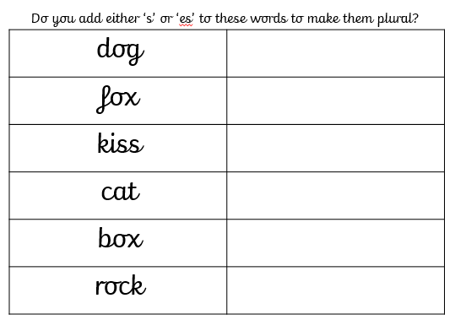
Writing -
Please use the link below to access daily sessions from BBC bitesize. They are really fun and are covering lots of different things! If you would like to as well – I will put an activity below about adding ‘s’ or ‘es’ as a suffix to make a word plural. I will also add a link to a BBC Supermovers which has a helpful song to help with your learning.
Here is the link for BBC Bitesize and also BBC Supermovers.
https://www.bbc.co.uk/bitesize/tags/zjpqqp3/year-1-and-p2-lessons
https://www.bbc.co.uk/teach/supermovers/ks1-english-the-spelling-bee-with-bertie- bee/zkwvmfr

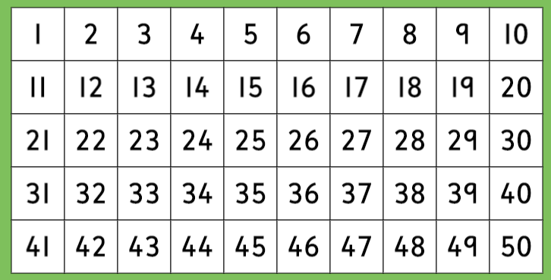
Maths -
For maths this week I am giving you two different options – I will put a link below to ‘White Rose Maths’ which has daily lessons that you can get involved in if you would like to revisit lessons we have done before and also begin to learn some new things. My task is below – I would like you to complete the activity about counting in fives.
https://whiterosemaths.com/homelearning/year-1/
Can you shade in all the numbers you would say if you were counting in groups of 5?

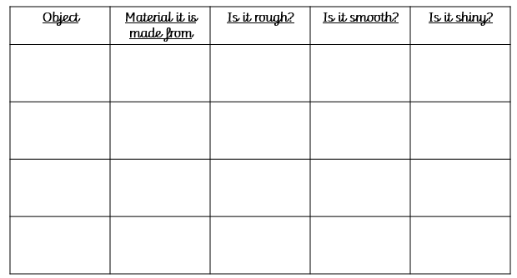
Science -
Our new science topic for this half term is all about ‘Everyday Materials’ – I would like you to find four different objects inside or outside of your house, they all have to be made from different materials. When you have chosen four objects – complete the table below!

PSHE -
In school this week we created a happy box and we filled it with things that bring us joy and happiness and I would like you to do the same. You can draw a picture and send it into school to show us, we would love to see!
Mindfulness/ PE
I would like you to try and do some physical exercise this week!
Here are some ideas:
Go for a walk with someone in your house
Try a new exercise – look at Joe Wicks or Cosmic Yoga on youtube!
Try and do as many star jumps as you can!
Make a go-noodle account and practise your dance moves! We have been completing the penguin dance in school.
Last but not least – stay safe!! We miss you very much!
Love Miss Tomlinson and Miss King x

