Year 1 Home Learning – Week Beginning 20th July
Hi Year 1! I hope you are all safe and well and I hope those of you that are at home are still doing your work and still smiling! Here are your home learning tasks to keep you busy this week.
As this is the last week of home learning I would just like to say thank-you to you all for a lovely year, I am sorry we didn’t get to spend the whole year together but thank you for all your hard work and I wish you all the best for Year 2.
Thank you for being a wonderful class for my first year at Ravenscroft x
Phonics – Choose one of the boxes below – you should know which sounds are your current phase. If you wanted you could even do both!
Can you read all five of the words below?
whispering
darkness
snowman
frightening
glowing
Can you put each word into a different sentence?

Can you read all five of the words below?
light
bright
sight
night
Can you put each word into a different sentence?

Monday
Tuesday
Wednesday
Thursday
Friday
Saturday
Sunday
Writing -
Please use the link below to access daily sessions from BBC bitesize. They are really fun and are covering lots of different things! If you would like to as well – I will put an activity below. Can you order the days of the week? Can you practise writing all of the days of the week and the numbers one – twenty?

one | two | three | four | five | six | seven | eight | nine | ten
eleven | twelve | thirteen | fourteen | fifteen | sixteen | seventeen | eighteen | nineteen | twenty

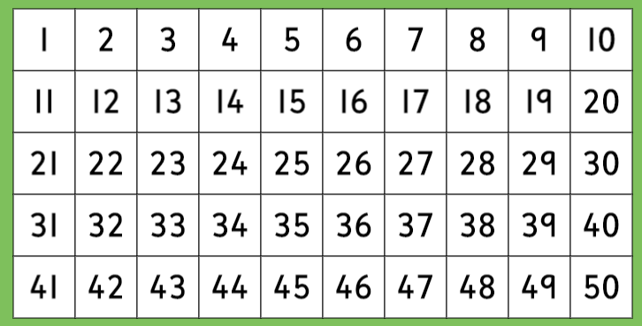
Maths -
For maths this week I am giving you two different options – I will put a link below to ‘White Rose Maths’ which has daily lessons that you can get involved in if you would like to revisit lessons we have done before and also begin to learn some new things. My task is below – I would like you to complete the activity about counting in twos. Can you listen to the song below to help you?
https://whiterosemaths.com/homelearning/year-1/
https://www.youtube.com/watch?v=MPda14jMNSA
https://www.bbc.co.uk/teach/supermovers/ks1-maths-counting-with-john-farnworth/zbct8xs
Can you shade in all the numbers you would say if you were counting in groups of 2? Think of your even numbers.
Food Technology -
In school this week we have designed and made our own pizzas. Could you do the same? Write a list of ingredients for your pizza and write down how you made it. You could even write a review when you have tasted it!
Mindfulness/ PE
I would like you to try and do some physical exercise this week!
Here are some ideas:
Go for a walk with someone in your house
Try a new exercise – look at Joe Wicks or Cosmic Yoga on youtube!
Try and do as many star jumps as you can!
Make a go-noodle account and practise your dance moves! We have been completing the penguin dance in school.
Last but not least – stay safe!! We miss you very much! Thank you for making this year a lovely year, we have loved being your teachers and we wish you all the best for Year 2. Have a lovely, safe summer and we will see you in September!
Love from,
Miss Tomlinson and Miss King xx

